Networks / PCA / connectedness: USDJPY and USDCAD
Method 28 / pair slice of eight-major system / Alpari D1 full available history

Study setup
Logical pair: USDJPY , USDCAD
Broker symbols: USDJPY_i , USDCAD_i
Snapshot: 2026-11-03_majors_alpari_D1
Timeframe: D1
Matched return window: 1999-01-05 to 2026-11-02 (UTC bar dates)
Matched return count n: 7186
System panel n: 7127
Dropped unfinished last bar dated 2026-11-03 UTC after a tick-volume check against the prior complete day.
VAR lag (BIC): 1; GFEVD horizon H=10
System TCI: 54.0425
Complete matched rows (Excel): USDJPY-USDCAD_Network_D1.xlsx

Method carried forward
Three system-level tools on the eight-major daily log-return panel. (1) Network distance d_ij = sqrt(2*(1-rho_ij)) from Pearson correlation. (2) PCA eigenvalues of the correlation matrix R (R v = lambda v). (3) Diebold-Yilmaz total connectedness index (TCI) from a VAR with generalised forecast-error variance decomposition (GFEVD), horizon H=10; lag order chosen by BIC with maxlags=10. TCI = 100 * sum_{i!=j} theta_tilde_ij / N after row-normalising GFEVD shares. Pair reports show d_ij, rho_ij, and the directed pair spillover shares from the system theta_tilde matrix. Edges and TCI are not trading signals.

Pair results
Pearson rho: 0.026272
Network distance d_ij: 1.395513
theta_tilde[USDJPY->USDCAD] (row USDJPY, col USDCAD): 0.002353
theta_tilde[USDCAD->USDJPY] (row USDCAD, col USDJPY): 0.000543
PCA lambda_1: 3.817794
PCA variance share PC1: 0.477224

Conclusion
For USDJPY-USDCAD: d_ij=1.3955 from rho=0.0263. Pair spillover shares 0.0024 / 0.0005. System TCI=54.04. Not a trading signal.

Pair charts
Daily closes

Daily log returns
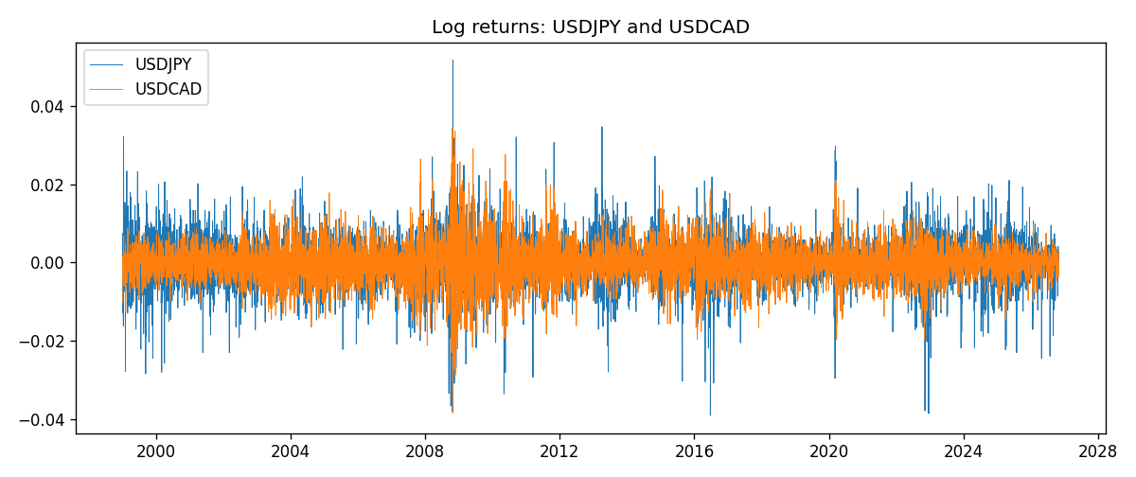

System charts (shared)
Correlation matrix

Distance matrix

PCA eigenvalues

GFEVD theta_tilde


Data report
First 15 matched rows
time | USDJPY_log_return | USDCAD_log_return
1999-01-05 | -0.00017868311 | -0.010131666
1999-01-06 | 0.0075660159 | -0.0003306769
1999-01-07 | -0.012851583 | 0.0015202092
1999-01-08 | -0.0047719894 | -0.0020495197
1999-01-11 | -0.016195423 | -0.0035137769
1999-01-12 | 0.032310364 | 0.0066194721
1999-01-13 | 0.0081373171 | 0.0045420214
1999-01-14 | 0 | 0.0069376546
1999-01-15 | 0.0055343401 | -0.0056905671
1999-01-18 | 8.7600193e-05 | 0.00098344542
1999-01-19 | -0.0056219403 | 0.002748513
1999-01-20 | -0.0053879917 | -0.0059646885
1999-01-21 | 0.0084664056 | -0.0042823796
1999-01-22 | 0.0060412564 | 0.0025057712
1999-01-25 | -0.0073594164 | 0.00085579808
Last 15 matched rows
time | USDJPY_log_return | USDCAD_log_return
2026-10-13 | -0.0018932826 | -0.0046395653
2026-10-14 | 7.5800166e-05 | 0.0015184751
2026-10-15 | -0.0018524319 | -0.0036101503
2026-10-16 | -0.00037976126 | -0.0034322068
2026-10-19 | 0.0034946841 | -0.0018835331
2026-10-20 | -0.0022546642 | -0.0037066008
2026-10-21 | -0.00032883504 | -0.00084691787
2026-10-22 | -0.0085942669 | -0.0026307268
2026-10-23 | 0.00035080446 | 2.85545e-05
2026-10-26 | 0.0041238746 | 5.7106554e-05
2026-10-27 | 0.0027651658 | 0.0025379458
2026-10-28 | -0.00095679538 | -0.0038379274
2026-10-29 | -0.00038043789 | -0.00011436495
2026-10-30 | -0.0010596481 | -0.0010298736
2026-11-02 | 0.0026438521 | 0.00061519094

